Micheal H. McCabe
Expert System Project
CSCI-370 Artificial Intelligence
Dr. Timothy Meyer
October 26, 2010

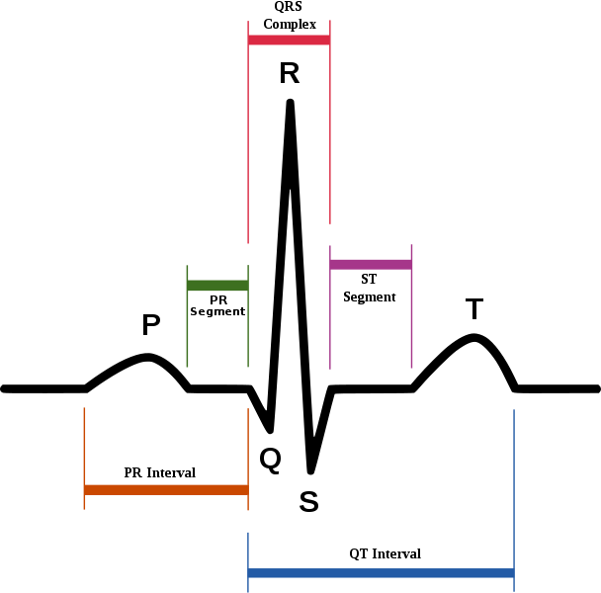
(Figure 1: Schematic Representation of an ECG Complex, showing individual waves)

The Program: ECG Rhythm Identification

Background: The identification of a particular ECG (electrocardiograph) Rhythm by paramedics, nurses, physicians, and soap-opera fanatics is highly subjective and prone to differences of opinion when a particular rhythm strip or recording is examined by two (or more) otherwise qualified individuals. The purpose of this program is to add a “joker” to the deck by implementing the decision-making process as an expert system using the CLIPS programming language. This program allows for easy identification of perhaps 20 ECG rhythms out of the myriad number known to medical science. The use of this program for actual diagnosis or treatment of cardiac arrhythmia is not recommended and would, at the least, constitute gross misfeasance and probably result in the death of the patient and subsequent cancellation of any malpractice insurances currently in effect.

How to use the program: First, load the rulebase into CLIPS using the (load) command. The CLIPS system reads the rulebase from the file and displays the status of each rule as it’s parsed into the rulebase:

CLIPS> (load “L:/rules.clp”)
Defining defrule: FLATLINE_RULE +j+j+j+j
Defining defrule: ASYSTOLE_RULE +j+j
Defining defrule: LOW_RATE_RULE +j+j
Defining defrule: NORMAL_RATE_RULE +j+j
Defining defrule: RAPID_RATE_RULE +j+j
Defining defrule: NORMAL_SINUS_RULE +j+j+j+j+j+j+j
Defining defrule: SINUS_TACHYCARDIA_RULE =j=j=j=j=j+j+j
Defining defrule: SINUS_BRADYCARDIA_RULE =j=j=j=j=j+j+j
Defining defrule: ATRIAL_FIBRILLATION_RULE =j=j=j+j+j+j+j
Defining defrule: ATRIAL_FLUTTER_RULE =j=j=j=j+j+j+j+j+j
Defining defrule: VENTRICULAR_FIBRILLATION_RULE =j+j+j+j+j+j
Defining defrule: VENTRICULAR_TACHYCARDIA_RULE =j=j=j=j=j+j+j
Defining defrule: VENTRICULAR_ECTOPY_RULE =j=j=j=j+j+j+j+j+j
Defining defrule: FIRST_DEGREE_AV_BLOCK_RULE =j=j=j=j=j+j+j+j+j
Defining defrule: SECOND_DEGREE_AV_BLOCK_TYPE_1_RULE =j=j=j=j=j+j+j+j+j
Defining defrule: SECOND_DEGREE_AV_BLOCK_Type_2_RULE =j=j=j=j=j+j+j+j+j
Defining defrule: THIRD_DEGREE_AV_BLOCK_RULE =j=j=j=j=j+j+j+j+j
Defining defrule: JUNCTIONAL_RHYTHM_RULE =j=j=j=j=j+j+j+j
Defining defrule: ACCELERATED_JUNCTIONAL_RHYTHM_RULE =j=j=j=j=j=j+j+j
Defining defrule: JUNCTIONAL_TACHYCARDIA_RHYTHM_RULE =j=j=j=j=j=j+j+j
Defining defrule: VENTRICULAR_RHYTHM_RULE =j=j=j+j+j+j+j
Defining defrule: PACED_RHYTHM_RULE =j=j=j=j=j+j+j+j+j
Defining defrule: SINUS_ARRHYTHMIA_RULE =j=j=j=j=j+j+j+j+j
Defining defrule: SINUS_ARREST_RULE =j=j=j=j=j+j+j+j+j
TRUE
CLIPS>

After loading the rulebase into CLIPS from the rules.clp file, the user asserts a number of facts to describe his observations of the ECG rhythm. For example, the user might make the following observations:

CLIPS> (assert(HEART_RATE 80)) ; The most basic of observations.
<Fact-1>
CLIPS> (assert(RHYTHM)) ; Another basic observation, indicating a rhythm DOES exist!
<Fact-2>
CLIPS> (assert(COMPLEXES)) ; QRS or similar ventricular complexes are visible in the rhythm
<Fact-3>
CLIPS> (assert(REGULAR)) ; Denoting that the rhythm is regular
<Fact-4>
CLIPS> (assert(P_WAVES)) ; Indicating that P Waves precede every QRS complex

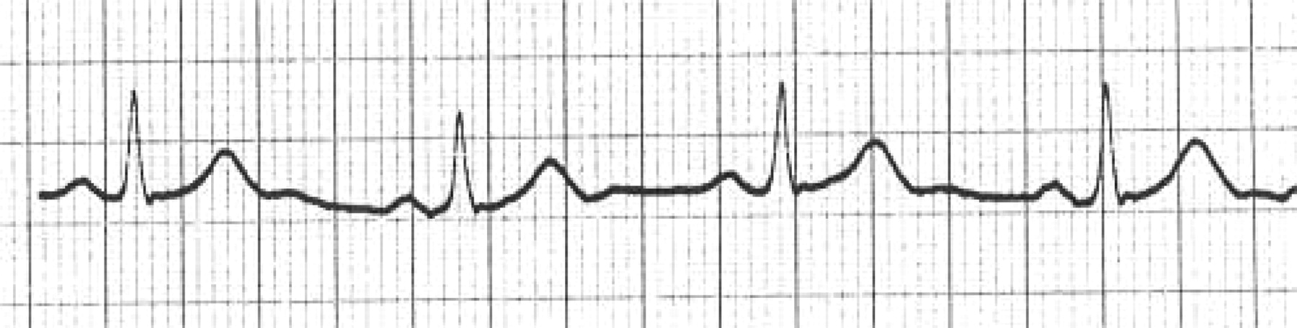
(Figure 2: The default rhythm)

At this point, the user has entered a fairly comprehensive set of facts about the observed ECG rhythm and can ask the program to attempt identification.

CLIPS> (run)
NORMAL RATE RULE INVOKED
NORMAL SINUS RULE INVOKED
CLIPS>

In this case, the program has identified the heart rate as within normal limits and indentified the rhythm as a “NORMAL SINUS RHYTHM.” This fact (albeit in abbreviated form) is added to the database for further analysis, perhaps by another program that suggests an appropriate therapy or performs additional analysis.

The user can display the current database of facts using the (fact) command as follows:

CLIPS> (facts)
f-0 (initial-fact)
f-1 (HEART_RATE 80)
f-2 (RHYTHM)
f-3 (COMPLEXES)
f-4 (REGULAR)
f-5 (P_WAVES)
f-6 (NORMAL_RATE)
f-7 (NSR)
For a total of 8 facts.
CLIPS>

This particular case is actually the most common ECG Rhythm encountered and can be loaded as the default database by invoking the (load) command to load the default facts into clips. This set of facts is also defined as the startup set and can be restored (after loading) by simply issuing a (reset) command.

CLIPS> (load "L:/facts.clp")
Defining deffacts: startup
TRUE
CLIPS> (reset)
CLIPS> (facts)
f-0 (initial-fact)
f-1 (HEART_RATE 80)
f-2 (RHYTHM)
f-3 (COMPLEXES)
f-4 (REGULAR)
f-5 (P_WAVES)
For a total of 6 facts.
CLIPS>

Let us now examine another case where that patient seems to have become unresponsive and suffered some form of ECG anomaly that requires dramatic intervention by the star (who is not a physician, but plays one on television.)

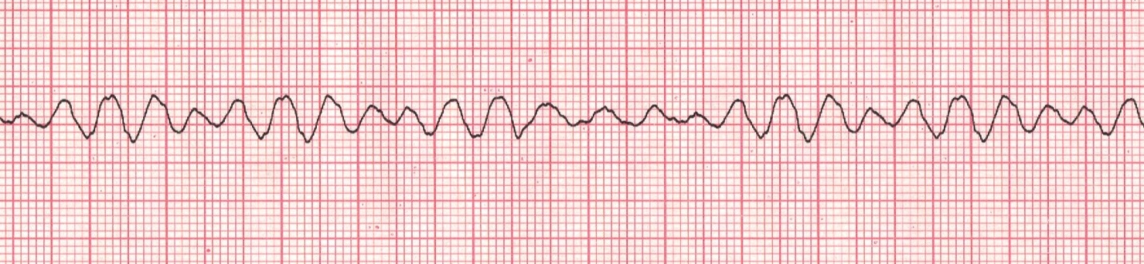
(Figure 3: A dramatic change in the ECG. Page Dr. House!)

This would be a good time to clear all the facts and start over with something other than the default rhythm. We really can’t see much in this rhythm besides an erratic baseline. There are no complexes, there’s not a discernable rhythm, no P-Waves, and the cardiotachograph doesn’t even give us a rate!

CLIPS> (clear)
CLIPS> (assert(ERRATIC_BASELINE))
<Fact-1>
CLIPS> (facts)
f-0 (initial-fact)
f-1 (ERRATIC_BASELINE)
For a total of 2 facts.
CLIPS> (load "L:/rules.clp")
Defining defrule: FLATLINE_RULE +j+j+j+j+j
Defining defrule: ASYSTOLE_RULE +j+j+j
Defining defrule: LOW_RATE_RULE +j+j
Defining defrule: NORMAL_RATE_RULE +j+j
Defining defrule: RAPID_RATE_RULE +j+j
Defining defrule: NORMAL_SINUS_RULE +j+j+j+j+j+j+j
Defining defrule: SINUS_TACHYCARDIA_RULE =j=j=j=j=j+j+j
Defining defrule: SINUS_BRADYCARDIA_RULE =j=j=j=j=j+j+j
Defining defrule: ATRIAL_FIBRILLATION_RULE =j=j=j+j+j+j+j
Defining defrule: ATRIAL_FLUTTER_RULE =j=j=j=j+j+j+j+j+j
Defining defrule: VENTRICULAR_FIBRILLATION_RULE =j+j+j+j+j+j
Defining defrule: VENTRICULAR_TACHYCARDIA_RULE =j=j=j=j=j+j+j
Defining defrule: VENTRICULAR_ECTOPY_RULE =j=j=j=j+j+j+j+j+j
Defining defrule: FIRST_DEGREE_AV_BLOCK_RULE =j=j=j=j=j+j+j+j+j
Defining defrule: SECOND_DEGREE_AV_BLOCK_TYPE_1_RULE =j=j=j=j=j+j+j+j+j
Defining defrule: SECOND_DEGREE_AV_BLOCK_Type_2_RULE =j=j=j=j=j+j+j+j+j
Defining defrule: THIRD_DEGREE_AV_BLOCK_RULE =j=j=j=j=j+j+j+j+j
Defining defrule: JUNCTIONAL_RHYTHM_RULE =j=j=j=j=j+j+j+j
Defining defrule: ACCELERATED_JUNCTIONAL_RHYTHM_RULE =j=j=j=j=j=j+j+j
Defining defrule: JUNCTIONAL_TACHYCARDIA_RHYTHM_RULE =j=j=j=j=j=j+j+j
Defining defrule: VENTRICULAR_RHYTHM_RULE =j=j=j+j+j+j+j
Defining defrule: PACED_RHYTHM_RULE =j=j=j=j=j+j+j+j+j
Defining defrule: SINUS_ARRHYTHMIA_RULE =j=j=j=j=j+j+j+j+j
Defining defrule: SINUS_ARREST_RULE =j=j=j=j=j+j+j+j+j
TRUE
CLIPS> (run)
VENTRICULAR FIBRILLATION RULE INVOKED
CLIPS>

As any fan of Emergency! Or Rescue: 911 can immediately tell you, it’s time to shock the patient with around 200 joules of electrical energy and (hopefully) jumpstart the myocardium!

A Handy-Dandy Dictionary of Assertions for this Program: (HDDAP)

The following assertions are understood by various rules in this program; feel free to use them to describe your mystery ECG Rhythm.

(assert(HEART_RATE nn)) This lets you tell the program the heart rate in beats per minute.

(assert(COMPLEXES)) Use this assertion to describe the presence of either a classical QRS complex or similar regularly occurring wave-complexes that comprise the ECG.

(assert(RHYTHM)) Use this assertion to describe the presence of a rhythm of any sort. As long as you have complexes that occur regularly and produce a heartbeat, you have a rhythm.

(assert(REGULAR)) This assertion indicates that the complexes in the rhythm occur at regular, predictable, intervals over time. If you measure the R-R or P-P distance with a ruler, you’ll get a consistent measurement.

(assert(ERRATIC_BASELINE) This assertion tells the program that your ECG lacks a clearly defined isoelectric line between complexes.

(assert(P_WAVES)) This indicates that a P-Wave precedes each complex in the rhythm. This is a diagnostic characteristic of all “sinus rhythms.”

(assert(FLATLINE)) This indicates the classic “flatline” ECG where myocardial death has occurred. It is a diagnostic indicator of asystole.

(assert(SAWTOOTH_WAVEFORM))This indicates that a “sawtooth” waveform is visible in the ECG. This is a diagnostic indicator of atrial flutter and similar atrial tachycardias.
(assert(WIDE_QRS) This indicates that abnormal, wide complexes are present in the ECG.

(assert(NARROW_COMPLEXES) This indicates that the QRS complexes are of normal width.

(assert((WIDE_PR_INTERVAL)) This indicates an abnormally long PR interval in each complex.

(assert((CONSTANT_PR_INTERVAL)) Although aberrant, the PR interval is of constant length.

(assert((WIDENING_PR_INTERVAL)) The PR interval is both abnormally long and getting longer.

(assert((DROPPED_BEATS)) An expected beat is dropped in an otherwise regular rhythm.

(assert((PRI_DISCONNECT)) There is no correlation between the number of P waves and the number of QRS complexes.

(assert(PACER_SPIKES)) Vertical spikes are visible preceding each QRS, indicating an artificial pacemaker.

Source Code of the rules.clp file:

;Micheal H. McCabe
;CSCI - 370 Artificial Intelligence
;Fall Semester 2010
;Dr. Timothy Meyer
;Expert System Miniproject (CLIPS)
;Rule Set for Cardiac Electrophysiology Program

;--------------------------------------------------------------------------

(defrule FLATLINE_RULE
(and
(not (COMPLEXES))
(not (P_WAVES))
(not (RHYTHM)))
(not (ERRATIC_BASELINE))
=>
(assert(FLATLINE))
(printout t "FLATLINE RULE INVOKED" crlf))

;--------------------------------------------------------------------------

(defrule ASYSTOLE_RULE
(and
(not (ERRATIC_BASELINE))
(FLATLINE))
=>
(assert(ASYSTOLE))
(printout t "ASYSTOLE RULE INVOKED" crlf))

;--------------------------------------------------------------------------

(defrule LOW_RATE_RULE
(HEART_RATE ?rate)
(test (< ?rate 60))
=>
(assert(SLOW_RATE))
(printout t "SLOW RATE RULE INVOKED" crlf))

;--------------------------------------------------------------------------

(defrule NORMAL_RATE_RULE
(HEART_RATE ?rate)
(and
(test (> ?rate 59 ))
(test (< ?rate 101)))
=>
(assert(NORMAL_RATE))
(printout t "NORMAL RATE RULE INVOKED" crlf))

;--------------------------------------------------------------------------

(defrule RAPID_RATE_RULE
(HEART_RATE ?rate)
(test (> ?rate 100 ))
=>
(assert(RAPID_RATE))
(printout t "RAPID RATE RULE INVOKED" crlf))

;---------------------------------------------------------------------------

(defrule NORMAL_SINUS_RULE
(and
(not(FLATLINE))
(RHYTHM)
(COMPLEXES)
(REGULAR)
(P_WAVES)
(NORMAL_RATE))
=>
(assert(NSR))
(printout t "NORMAL SINUS RULE INVOKED" crlf))

;--------------------------------------------------------------------------

(defrule SINUS_TACHYCARDIA_RULE
(and
(not(FLATLINE))
(RHYTHM)
(COMPLEXES)
(REGULAR)
(P_WAVES)
(RAPID_RATE))
=>
(assert(SINUS_TACH))
(printout t "SINUS TACHYCARDIA RULE INVOKED" crlf))

;--------------------------------------------------------------------------

(defrule SINUS_BRADYCARDIA_RULE
(and
(not(FLATLINE))
(RHYTHM)
(COMPLEXES)
(REGULAR)
(P_WAVES)
(SLOW_RATE))
=>
(assert(SINUS_BRADY))
(printout t "SINUS BRADYCARDIA RULE INVOKED" crlf))

;--------------------------------------------------------------------------

(defrule ATRIAL_FIBRILLATION_RULE
(and
(not(FLATLINE))
(RHYTHM)
(COMPLEXES)
(not(REGULAR))
(not(P_WAVES))
(ERRATIC_BASELINE))
=>
(assert(A-FIB))
(printout t "ATRIAL FIBRILLATION RULE INVOKED" crlf))

;--------------------------------------------------------------------------

(defrule ATRIAL_FLUTTER_RULE
(and
(not(FLATLINE))
(RHYTHM)
(COMPLEXES)
(REGULAR)
(not(P_WAVES))
(not(ERRATIC_BASELINE))
(RAPID_RATE)
(SAWTOOTH_WAVEFORM))
=>
(assert(ATRIAL_FLUTTER))
(printout t "ATRIAL FLUTTER RULE INVOKED" crlf))

;--------------------------------------------------------------------------

(defrule VENTRICULAR_FIBRILLATION_RULE
(and
(not(FLATLINE))
(not(RHYTHM))
(not(P_WAVES))
(not(COMPLEXES))
(ERRATIC_BASELINE))
=>
(assert(VENTRICULAR_FIBRILLATION))
(printout t "VENTRICULAR FIBRILLATION RULE INVOKED" crlf))

;--------------------------------------------------------------------------

(defrule VENTRICULAR_TACHYCARDIA_RULE
(and
(not(FLATLINE))
(RHYTHM)
(COMPLEXES)
(REGULAR)
(not(P_WAVES))
(WIDE_QRS))
=>
(assert(VENTRICULAR_TACHYCARDIA))
(printout t "VENTRICULAR TACHYCARDIA RULE INVOKED" crlf))

;--------------------------------------------------------------------------

(defrule VENTRICULAR_ECTOPY_RULE
(and
(not(FLATLINE))
(RHYTHM)
(COMPLEXES)
(not(REGULAR))
(P_WAVES)
(NORMAL_RATE)
(NARROW_COMPLEXES)
(WIDE_QRS))
=>
(assert(PVCS))
(printout t "VENTRICULAR ECTOPY RULE INVOKED" crlf))

;--------------------------------------------------------------------------

(defrule FIRST_DEGREE_AV_BLOCK_RULE
(and
(not(FLATLINE))
(RHYTHM)
(COMPLEXES)
(REGULAR)
(P_WAVES)
(WIDE_PR_INTERVAL)
(CONSTANT_PR_INTERVAL)
(NARROW_COMPLEXES))
=>
(assert(FIRST_DEGREE_BLOCK))
(printout t "FIRST DEGREE AV BLOCK INVOKED" crlf))

;--------------------------------------------------------------------------

(defrule SECOND_DEGREE_AV_BLOCK_TYPE_1_RULE ; Wenckebach
(and
(not(FLATLINE))
(RHYTHM)
(COMPLEXES)
(not(REGULAR))
(P_WAVES)
(WIDENING_PR_INTERVAL)
(DROPPED_BEATS)
(NARROW_COMPLEXES))
=>
(assert(SECOND_DEGREE_AV_BLOCK_TYPE_1))
(printout t "SECOND DEGREE AV BLOCK TYPE 1 RULE INVOKED" crlf))

;--------------------------------------------------------------------------

(defrule SECOND_DEGREE_AV_BLOCK_Type_2_RULE ; Classical Mobitz II
(and
(not(FLATLINE))
(RHYTHM)
(COMPLEXES)
(not(REGULAR))
(P_WAVES)
(CONSTANT_PR_INTERVAL)
(DROPPED_BEATS)
(NARROW_COMPLEXES))
=>
(assert(SECOND_DEGREE_AV_BLOCK_TYPE_2))
(printout t "SECOND DEGREE AV BLOCK TYPE 2 RULE INVOKED" crlf))

;--------------------------------------------------------------------------

(defrule THIRD_DEGREE_AV_BLOCK_RULE
(and
(not(FLATLINE))
(RHYTHM)
(COMPLEXES)
(REGULAR)
(P_WAVES)
(not (CONSTANT_PR_INTERVAL))
(PRI_DISCONNECT)
(NARROW_COMPLEXES))
=>
(assert(THIRD_DEGREE_AV_BLOCK))
(printout t "THIRD DEGREE AV BLOCK RULE INVOKED" crlf))

;--------------------------------------------------------------------------

(defrule JUNCTIONAL_RHYTHM_RULE
(and
(not(FLATLINE))
(RHYTHM)
(COMPLEXES)
(REGULAR)
(not (P_WAVES))
(NARROW_COMPLEXES)
(SLOW_RATE))
=>
(assert(JUNCTIONAL_RHYTHM))
(printout t "JUNCTIONAL RHYTHM RULE INVOKED" crlf))

;--------------------------------------------------------------------------

(defrule ACCELERATED_JUNCTIONAL_RHYTHM_RULE
(and
(not(FLATLINE))
(RHYTHM)
(COMPLEXES)
(REGULAR)
(not (P_WAVES))
(NARROW_COMPLEXES)
(NORMAL_RATE))
=>
(assert(ACCELERATED_JUNCTIONAL_RHYTHM))
(printout t "JUNCTIONAL RHYTHM RULE INVOKED" crlf))

;--------------------------------------------------------------------------

(defrule JUNCTIONAL_TACHYCARDIA_RHYTHM_RULE
(and
(not(FLATLINE))
(RHYTHM)
(COMPLEXES)
(REGULAR)
(not (P_WAVES))
(NARROW_COMPLEXES)
(FAST_RATE))
=>
(assert(JUNCTIONAL_TACHYCARDIA))
(printout t "JUNCTIONAL TACHYCARDIA RULE INVOKED" crlf))

;--------------------------------------------------------------------------

(defrule VENTRICULAR_RHYTHM_RULE
(and
(not(FLATLINE))
(RHYTHM)
(COMPLEXES)
(not (P_WAVES))
(WIDE_COMPLEXES)
(SLOW_RATE))
=>
(assert(VENTRICULAR RHYTHM))
(printout t "VENTRICULAR RHYTHM RULE INVOKED" crlf))

;--------------------------------------------------------------------------

(defrule PACED_RHYTHM_RULE
(and
(not(FLATLINE))
(RHYTHM)
(COMPLEXES)
(REGULAR)
(not (P_WAVES))
(PACER_SPIKES)
(WIDE_COMPLEXES)
(NORMAL_RATE))
=>
(assert(PACED_RHYTHM))
(printout t "PACED RHYTHM RULE INVOKED" crlf))

;--------------------------------------------------------------------------

(defrule SINUS_ARRHYTHMIA_RULE
(and
(not(FLATLINE))
(RHYTHM)
(COMPLEXES)
(not (REGULAR))
(P_WAVES)
(not (DROPPED_BEATS))
(NARROW_COMPLEX)
(NORMAL_RATE))
=>
(assert(SINUS_ARRHYTHMIA))
(printout t "SINUS ARRHYTHMIA RULE INVOKED" crlf))

;---------------------------------------------------------------------------

(defrule SINUS_ARREST_RULE
(and
(not(FLATLINE))
(RHYTHM)
(COMPLEXES)
(not (REGULAR))
(P_WAVES)
(DROPPED_BEATS)
(NARROW_COMPLEX)
(NORMAL_RATE))
=>
(assert(SINUS_ARREST))
(printout t "SINUS ARREST RULE INVOKED" crlf))

;---------------------------------------------------------------------------

Source Code of the facts.clp file:

(deffacts startup (HEART_RATE 80) (RHYTHM) (COMPLEXES) (REGULAR) (P_WAVES))

